**Open Source Cubesat using COTS Electronics**

Zachary Cullen, Shawn Nase, Mark Bright, Jimmy Oakes

Penn State University

5/6/2020

Remember to look into limits of electronics

**Index**

**Abstract**

**Nomenclature**

Table of Equations

**Introduction**

* 1. Objective Motivation/’Hypothesis”
  2. Why did we do this work (justification of objective)
  3. Background
     1. Things people did previously and how
     2. Our initial approach?
  4. Guidance to reader
     1. What should reader watch for
     2. Points of interest
     3. What strategy we used
  5. Summary/Conclusion
     1. Expectations regarding conclusion

Cost Estimates

Table of Anticipated Costs

Physical Obstacles

Tubesat Architecture - include several images, text explaining choices for the overall design

1. Housing/caddy
2. PMC
3. DPC
4. Solar cells
5. Additional communications module

**Introduction**

The objective of this paper is to present a low cost, open source, modular satellite design and support its feasibility with accompanying analysis. In February 2020, the design was initially predicted to take roughly 16 weeks and $1500 to plan, test, and implement. The objective then was to physically implement a COTS circuit contained within a housing that can consistently operate a clock to blink an LED while subject to the simulated environmental effects of space. Due to limitations imposed by the COVID-19 pandemic, focus has since been shifted from an experimental approach to an analytical approach. Analysis and modeling of the satellite’s housing in order to support feasibility under environmental conditions have been conducted. If successful, the design will open up opportunities in space to those with exceptionally low funds. The novel design is also intended to promote further research into using alternate electronics for CubeSats, which will ideally continue to drive down costs once thoroughly investigated.

Current satellite designs all use space rated components. See reference [6] for specific details regarding space rated components. Such components drive up cost immensely. There has been a push recently for small cube-shaped satellites or ‘CubeSats’, which are generally marketed towards low budget communities such as academics, independent researchers, and hobbyists. In the CubeSat space, the general trend has been to reduce the satellite size, which greatly reduces cost. The range of cost for such satellites is vast, ranging from less than $1000 prelaunch (see reference [2] for details) to hundreds of thousands of dollars. The lowest cost designs are not yet open source.

Risks associated with the design are primarily environmental effects. Thermal effects are mitigated via an insulated housing design, and calculations supporting the insulation’s ability to deal with thermal effects have been conducted. A pressurized container is used to resolve vacuum effects and minimize gas leakage. Calculations regarding the penetration of ionizing radiation through the casing material have been conducted, and the casing material and thickness selected accordingly.

**Systems Overview**

Following COVID-19, the physical implementation of the Tubesat became beyond the scope of this report, but the following is intended to give a detailed overview of all the satellite’s proposed systems, including those which cannot be thoroughly analyzed with computer simulations or mathematical models.

All electrical circuitry of the satellite, with the exception of power wires feeding energy from the solar modules into the core, will be implemented on a PCB located in a caddy within the core casing. The PCB will sit atop and be thermally coupled to a bank of Lithium manganese oxide 18650 cells. The electrical systems will be categorized as follows: solar, battery, power management circuit (PMC), and digital processing circuit (DPC).

The solar modules incorporated into the design will consist of six 5” by 5” 3.6 W solar cells, each with 21.8 % efficiency. These solar modules will connect electrically in series prior to being fed to the power management circuit within the core of the satellite.

The battery module of the design will consist of four cylindrical lithium manganese oxide 18650 cells placed in series. Each cell is rated for 4.2 V nominal, or fully charged, and 3 V depleted. Therefore, the nominal voltage of the battery module will be 16.8 V rated for 2.2 AH, and will be considered depleted when the series voltage is approximately 12 V.

The power management circuit (PMC) consists of several subsystems. A single-ended primary-inductor converter (SEPIC) enables voltage up/down conversion through fast MOSFET switching and coupled inductors. Current bypass MOSFETs enable dynamic cell balancing. A microcontroller that uses firmware implemented battery chemistry profiling and SOC manipulation algorithms allows for high-efficiency energy transfer. This controller mechanism incorporates I2C communications capability that can be modulated onto satellite uplink/downlink data channels.

The digital processing system will consist of an Atmega 2560 IC. This 8-bit microcontroller incorporates 256 KB of flash memory, 8 KB of RAM, and 16 MIPS capability at a clock frequency of 16 MHz while maintaining low power consumption.

For the mechanical design including the outermost housing, the length/width/depth dimensions are expected to be 6” by 6” by 6’’. On the outermost layer, six 1/16” thick aluminum solar panels will form a cube. Within the structure to support the panels, a recession will house an insulated tube that contains the battery, PMC, and DPC modules. The tube will be installed into the internal compartment of the satellite through one of several gaps. The remaining gaps will be of a modular design and allow multiple tubes containing mission equipment to be installed and linked together in terms of power and communication. The core casing will protect the internal electronics and caddy material from ionizing radiation found in space. Hexagonal voids within the printed caddy will provide thermal isolation of interior components. A sealed core casing will allow atmospherically pressurized air to be held inside the container.

The following images are intended to provide a detailed visualization of the Tubesat housing, the subsystem of interest for the analysis presented later in this paper.

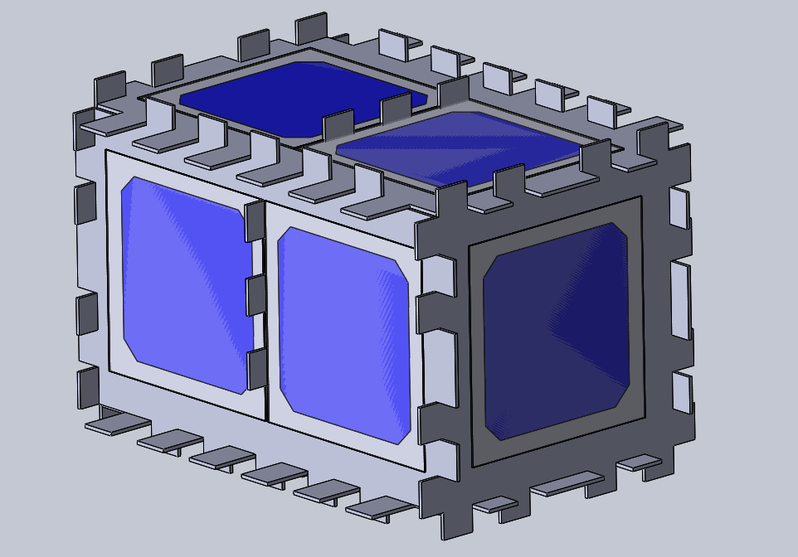

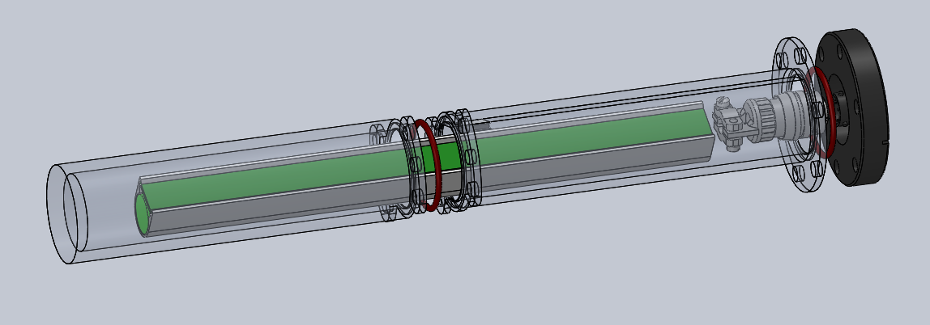

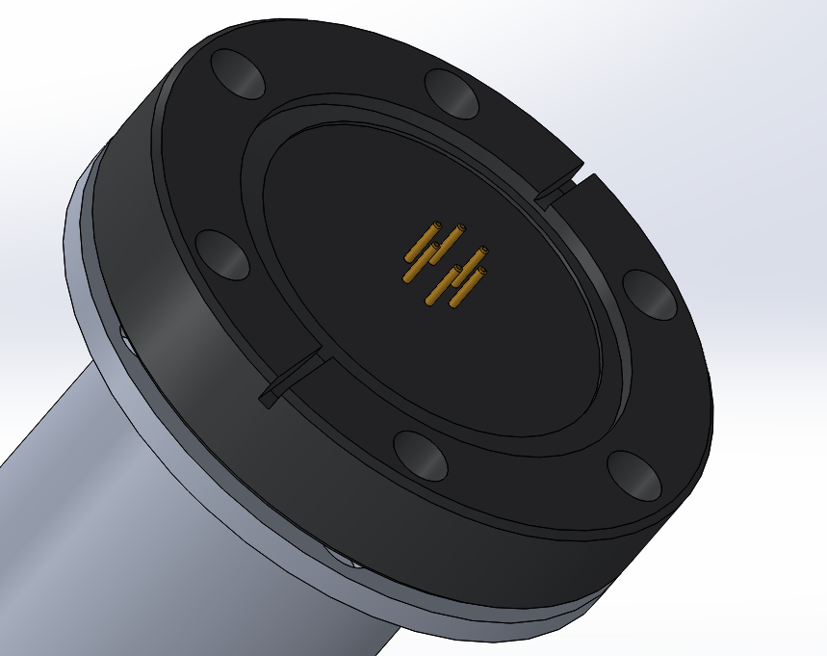

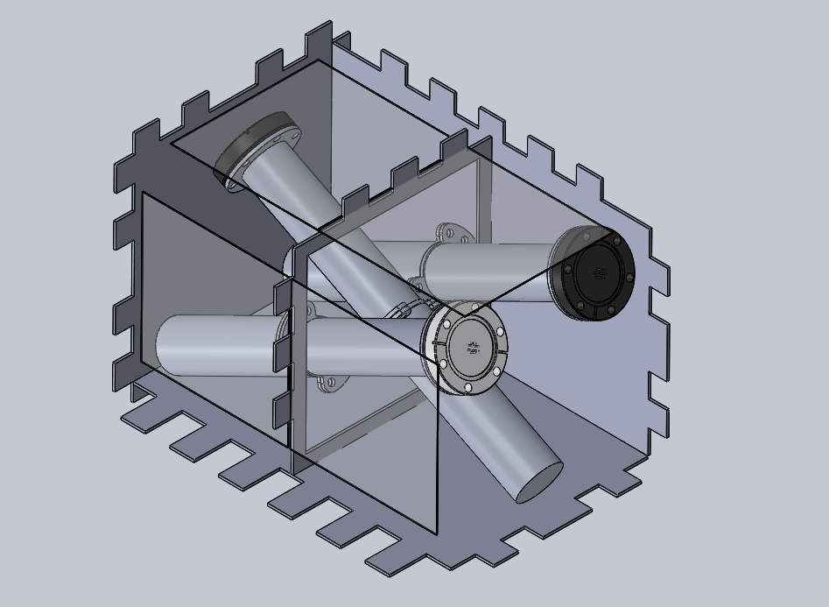

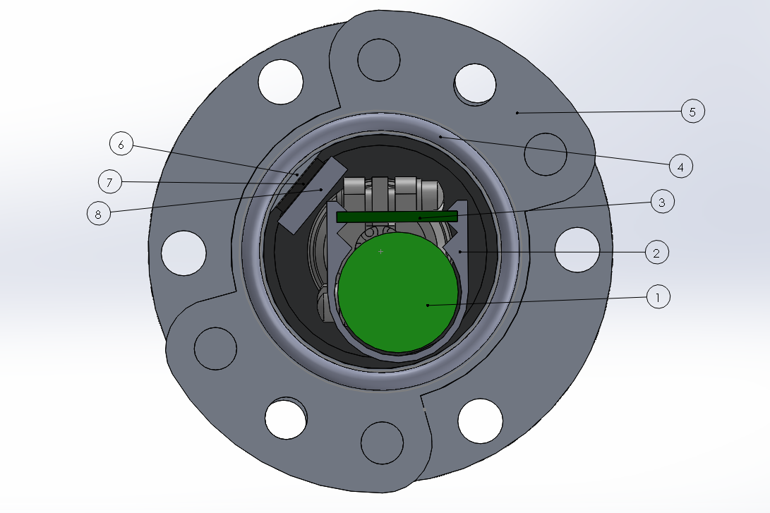

**Results and Discussion**

**Air Leakage**

Calculation for PSI in Tubesat, expectation after 6 months

Discussion of calculation

**Thermal Modeling**

Thermal Radiation - image and explanation

Figure X: Thermal Radiation is Negligible

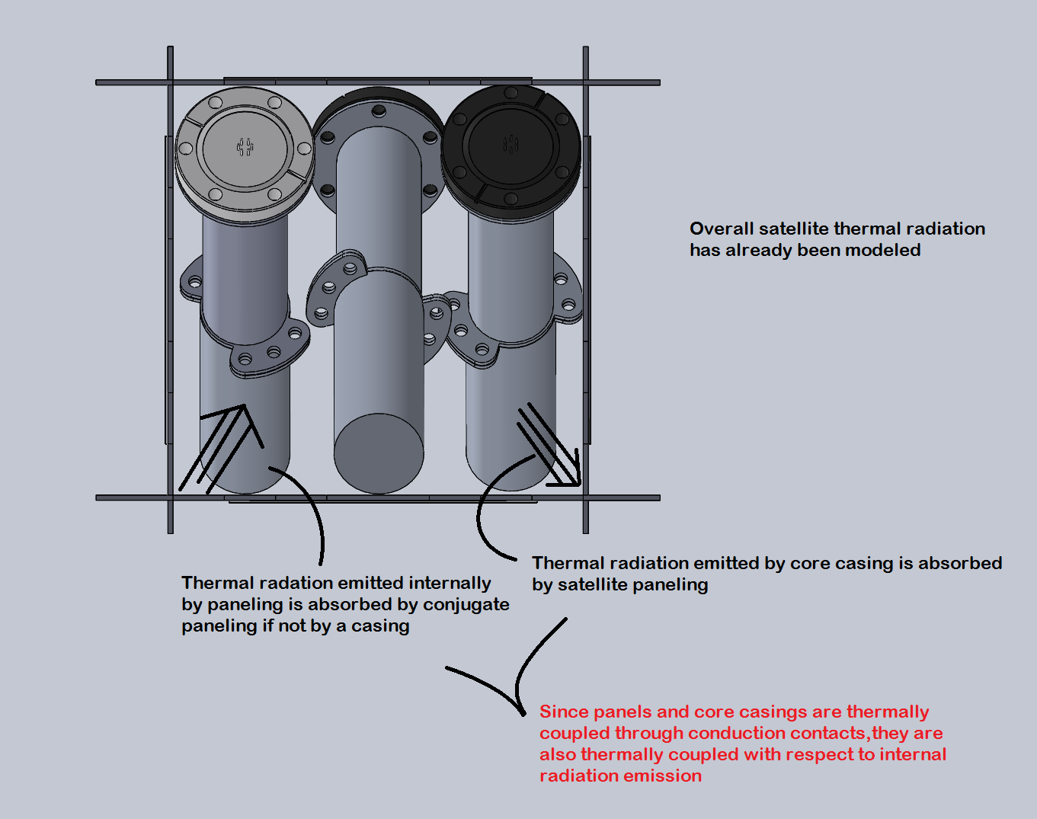

Figure X

Satellite Equilbirum Temperature Calculations - refer to the paper

CFD Analysis - criteria in table/list format, resultant images from analysis with captions

Table X

|  |
| --- |
| **Criteria for CFD Analysis** |
| Satellite equilibrium temperature in sunlight: 24°C |
| Satellite equilibrium temperature in shade: -75°C |
| Caddy material: ABS Plastic |
| Casing material: 6061-T6 Al |
| Symmetrical design (due to assumption cylinders) |
| No forced convection elements |
| Wall heat transfer coefficient: 500 W/(m^2 * K) |

Thermal Convection - assumptions in table/list format, results in table/image/paragraph format

Table X

|  |  |  |  |  |
| --- | --- | --- | --- | --- |
| **Thermal Convection Results** | | | | |
| **Casing T**  **(F)** | **Caddy T**  **(F)** | **Time**  **(s)** | **Transfer**  **(J)** | **Direction** |
| -100 L | 70 UL | 2520 s | 6.1608E-12 | Ca to CC |
| -100 L | 30 UL | 2520 s | 8.4621E-12 | Ca to CC |
| -100 L | -15 UL | 2520 s | 1.5183E-12 | Ca to CC |
| 70 L | -100 UL | 2520 s | 5.4865E-12 | CC to Ca |
| 30 L | -100 UL | 2520 s | 5.4865E-12 | CC to Ca |
| -15 L | -100 UL | 2520 s | 5.4865E-12 | CC to Ca |
| Note:  L and UL stand for locked and unlocked, respectively  Ca and CC stand caddy and core casing, respectively | | | | |

Thermal Conduction - assumptions in paragraph and table/list format, results in image/paragraph format

Table X

|  |
| --- |
| **Criteria for Conduction Simulation** |
| Standoff material: Brass |
| Standoff quantity: 30 |
| Standoff surface area: 0.20268347 mm^2 |
| Casing material: 6061-T6 Al |
| Temperature differential: -100°F to 70°F (max) |
| Simulation time: 1 hour |

**Power Budget**

Images with satellite positioning

Table with Power Budget - caption with references

Energy consumption/provision

Discuss modularity

Figure X: Tubesat in Sun

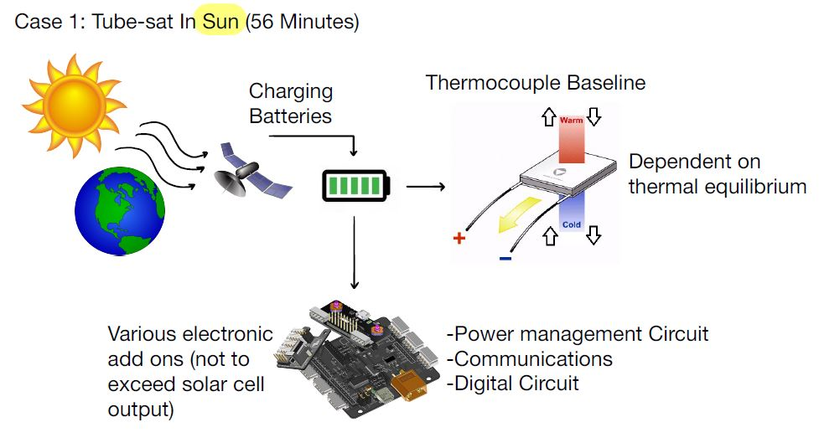

Figure X serves as a visual guide used for power calculations in the sun.

Figure X: Tubesat in Shade

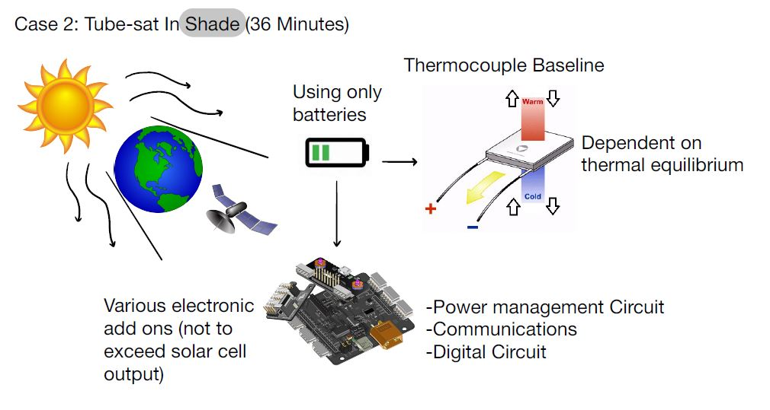

Figure X serves as a visual guide used for power calculations in the shade.

Table X: Power Budget

|  |  |  |  |
| --- | --- | --- | --- |
| **Power Budget** | | | |
| Subsystem | Power Requirement (J/s) | Energy Consumed/Provided in Shade (J) | Energy Consumed/Provided in Sun (J) |
| Communications Power | 2.5 | -8400 | -5400 |
| PMC Power | 0.15 | -504 | -324 |
| DPC Power | 0.095 | -319.2 | -205.2 |
| Solar cell | -12.5 | 0 | 42000 |

**Conclusion**

Feasibility

Path to building/testing in future work - maybe discuss previous work attempt to fit circuits onto PCB here

**References**

[1] D. Dinh, “Thermal Modeling of Nanosat”, San Jose State University, San Jose, CA, USA, 2012.[Online]. Available: <https://scholarworks.sjsu.edu/cgi/viewcontent.cgi?referer=&httpsredir=1&article=7740&context=etd_theses>

[2] Seckel, Scott, and Monique Clement. “The next Big Thing in Space Is Really, Really Small.” ASU Now: Access, Excellence, Impact, ASU News, 2017. [Online]. Available: asunow.asu.edu/20160406-creativity-asu-suncube-femtosat-space-exploration-for-everyone.

[3] Atmel, “Atmel ATmega640/V-1280/V-1281/V-2560/V-2561/V”, 1600 Technology Drive, San Jose, CA 95110 USA, 2014. [Online]. Available: <http://ww1.microchip.com/downloads/en/DeviceDoc/Atmel-2549-8-bit-AVR-Microcontroller-ATmega640-1280-1281-2560-2561_datasheet.pdf>

[4] CYPRESS, “CY8C27143/CY8C27243 CY8C27443/CY8C27543 CY8C27643 PSoC® Programmable System-on-Chip™, 2018. [Online]. Available: <https://www.cypress.com/file/134906/download>

[5] Custom Thermoelectric, “TEC Specification Sheet”, 11941 Industrial Park Road, STE 5, Bishopville, MD 21813, 2018. [Online]. Available: <https://customthermoelectric.com/media/wysiwyg/TEC_spec_sheets/07101-9330-48RF3_spec_sht.pdf>

[6] NASA, “NASA Parts Selection List (NPSL)”, NASA Goddard Space Flight Center, Greenbelt, MD 20771, 2016. [Online]. Available: <https://nepp.nasa.gov/npsl/>